**Advantage Physical Therapy**

**Medical History**

Patient Name: _______________________________________ Date of next physician’s visit? _________

Date of Injury:___/___/_____ Have you had a related surgery? □ Yes □ No

Have you ever had these symptoms before? □ Yes □ No Date of surgery:___/___/______

Age: _____ Height: ________ Weight: ________ Blood Pressure (if known): _____________

Do you have any of the following:

Yes No Yes No

Diabetes □ □ Seizures □ □

High Blood Pressure □ □ Allergies □ □

Heart Disease □ □ Arthritis □ □

Heart Attack □ □ Osteoporosis □ □

Pace Maker □ □ Infectious Disease □ □

Pregnant □ □ Depression □ □

Cancer □ □ Smoking □ □

Asthma □ □ Other: _____________________

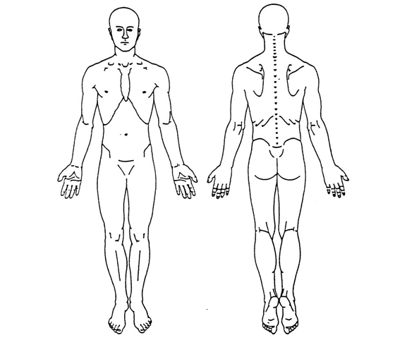Indicate areas of pain:

Circle number that corresponds with worst and least pain intensity:

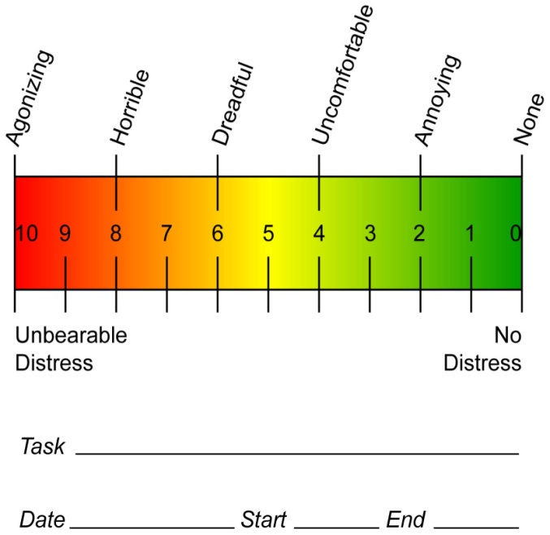

Are you presently taking medication? □ Yes □ No

If yes, please list what medications and for what condition: ______________________________

_____________________________________________________________________________________

Is there any other information regarding your past medical history that we should know about? _______

_____________________________________________________________________________________

Signature: ________________________________________ Date: ________________